PRACTICAL 5: CISCO DEVICE ACCESS AND BASIC CONFIGURATION
Objective
Access Cisco IOS and perform basic device configuration.
Equipment
- Console Cables
- Cisco 1941 Router
- Cisco ISR4331 Router
- Cisco Catalyst 3560 Switch

Activities
- Access Cisco devices using console cables.
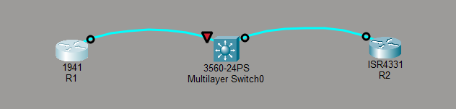
- Configure hostname.
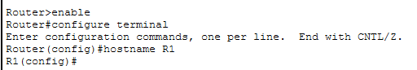
Figure 1: R1 hostname
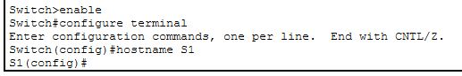
Figure 2: S1 hostname
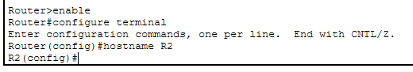
Figure 3: R2 hostname

- Configure passwords.
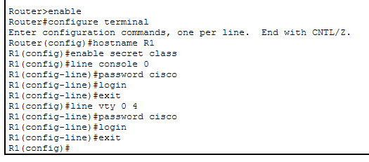
Figure 4: R1 password config
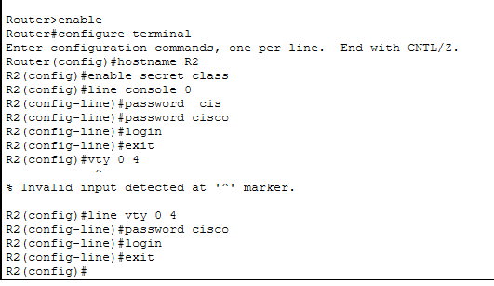
Figure 5: R2 password config
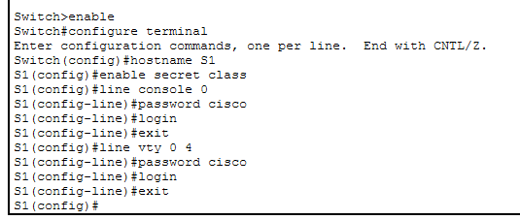
Figure 6: S1 password config
- Configure login banner.
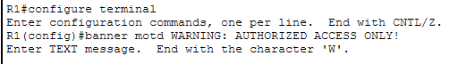
Figure 7: R1

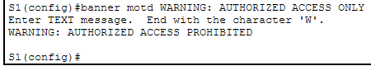
Figure 8: S1
5. Save configurations.
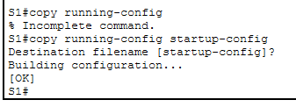
Figure 9: S1 running config startup-config

Deliverable
Configuration screenshots and configuration file.
Assessment Rubric (10 Marks) Criteria | Marks
Console connectivity | 2
IOS navigation | 3
Device configuration | 3
Save and verify configuration | 2
Total | 10

